**ABC Cloud Migration: On-prem to AWS**

**Assignment 5**

Aneesha Mathew

Dhrumilkumar Panchal

Prabhnoor Kaur

**Cloud Technologies, Conestoga College**

**Digital Solutions Management 1524G**

Fadi Abd Ulhamid

04 December 2023

**Table of Contents**

Introduction 3

Preparation 3

Observations 4

Challenges and Troubleshoot 6

Screenshots 8

Reflection 19

References 20

**ABC Clothing Migration from On-prem to AWS**

## Introduction

The project aims to transition ABC Clothing's on-premises e-commerce platform to AWS, enhancing scalability and security. We perform migration of static assets using S3, implement CloudFront for efficient content delivery to EC2 instances for hosting. The focus will be on having an accessible website with AWS security protocols, achieving scalable traffic management through Auto Scaling, and maintaining cost-effectiveness via resource optimization. The end goal is a responsive, secure AWS-hosted e-commerce site capable of handling varying traffic levels efficiently.

The image below gives a brief description of the services used.

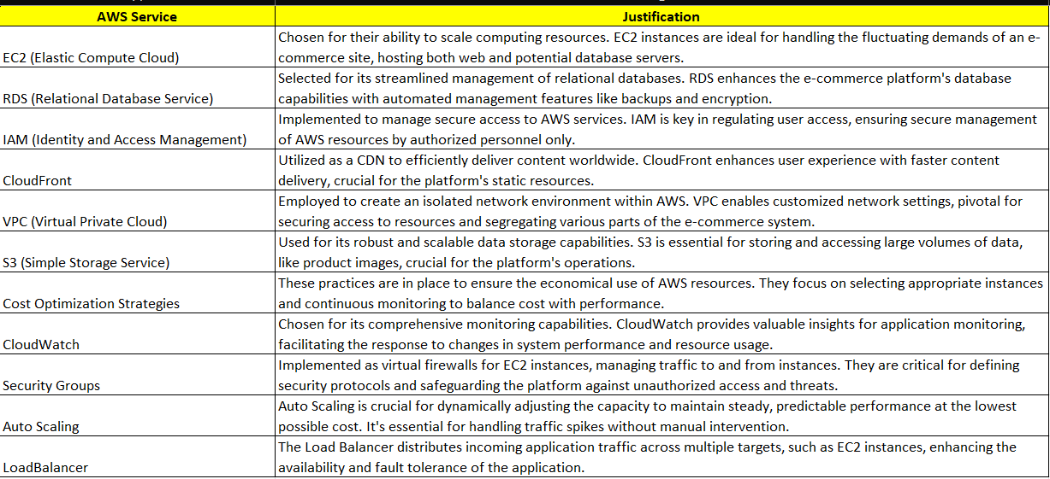

## Preparation

In preparing for ABC Clothing's e-commerce platform migration to AWS cloud, our team did a lot of research and planning. We studied AWS services like EC2, S3, CloudFront, IAM, and Auto Scaling in depth. We had dived deep into AWS documentation and tutorials that played pivotal role in understanding how to integrate these services effectively for a functional e-commerce platform.

In our initial analysis of ABC Clothing's existing infrastructure, we meticulously examined server requirements, database configurations, and the management of critical elements such as images and code. Comparing the current setup, which utilizes phpMyAdmin, with various cloud migration strategies, we concluded that the most suitable approach is the "lift and shift" method. Our implementation involved establishing an EC2 instance, opting for a free Linux server running on a t2.micro instance.

Simultaneously, we placed a strong emphasis on security best practices to ensure a robust and safeguarded transition. Our focus extended to network security measures and the careful design of IAM (Identity and Access Management) roles and policies. This comprehensive approach not only guarantees the security of the migration process but also ensures seamless interconnectivity within the cloud environment.

Furthermore, our exploration delved into understanding the diverse AWS pricing models, strategically aimed at optimizing costs effectively. While recognizing the use for SSL/TLS certificates to ensure secure HTTPS connections, we also took into consideration the associated expenses and limitations of acquiring a domain through AWS. To mitigate costs, we judiciously configured the security group to grant access exclusively for HTTP and ICMP.

Our journey into the intricacies of bootstrapping proved to be pivotal. This process involved the meticulous setup of a server and the creation of web pages, providing valuable insights into the practical application of cloud technology. These foundational steps not only played a crucial role in bringing the website online but also served as an invaluable learning experience, deepening our understanding of leveraging cloud technologies in real-world scenarios.

## Observations

Creating an EC2 Instance – ABCcloud

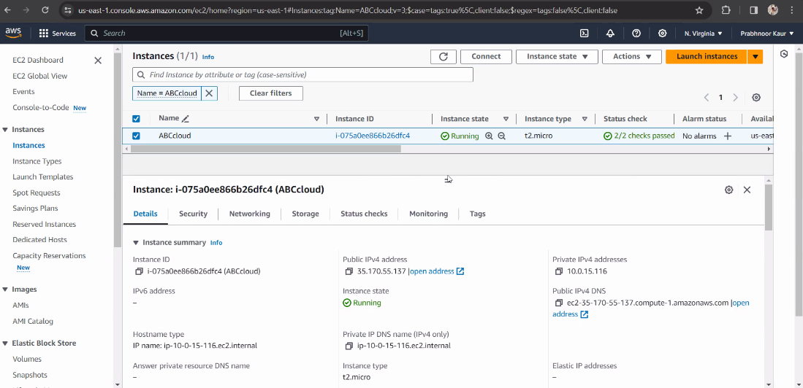

EC2 instance with conncted IAM, VPC, Subnet

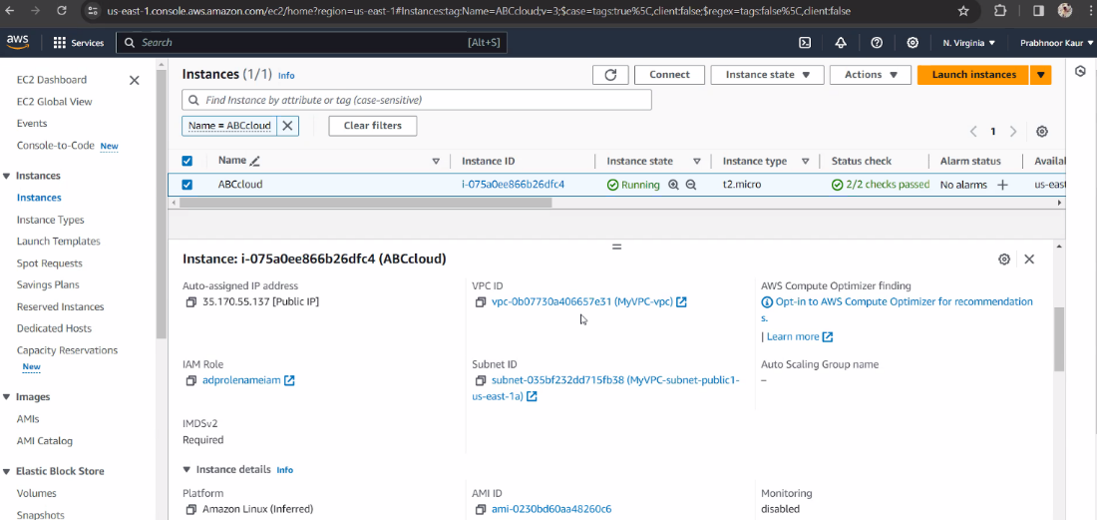

Connecting to the EC2 Instance Using SSH Command

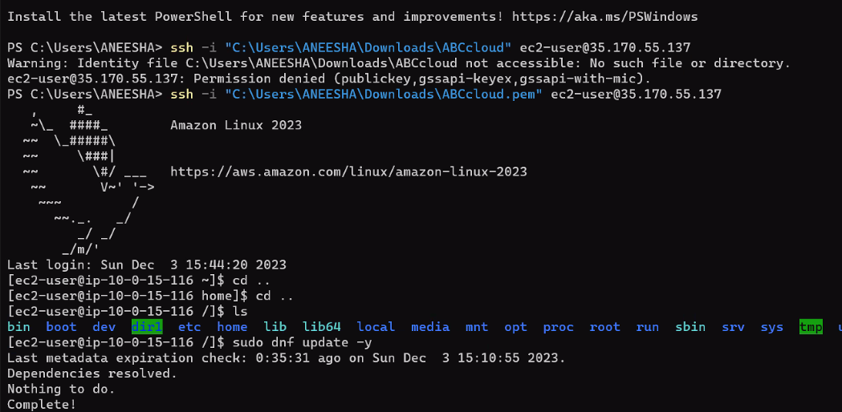

Installation of webserver, php, and mysql database

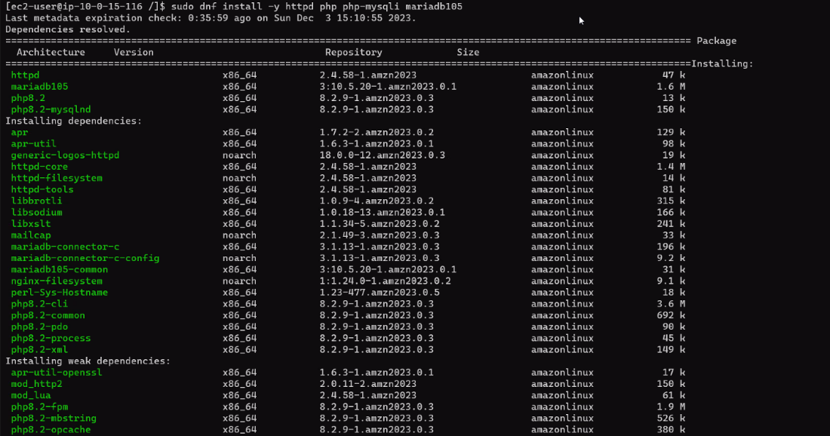

Enabling of Services and Permission

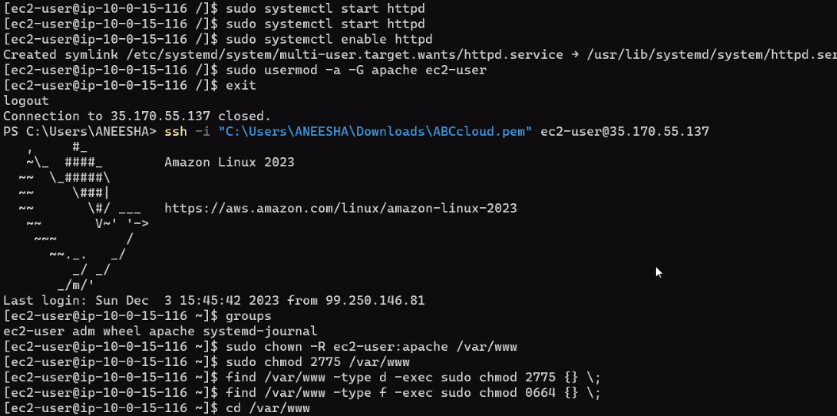

Database Connection

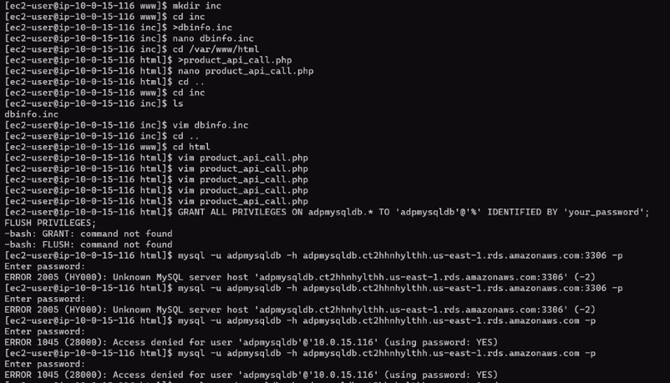

## Challenges and Troubleshoot

After DB installation on the webserver, we are unable to connect it with RDS.

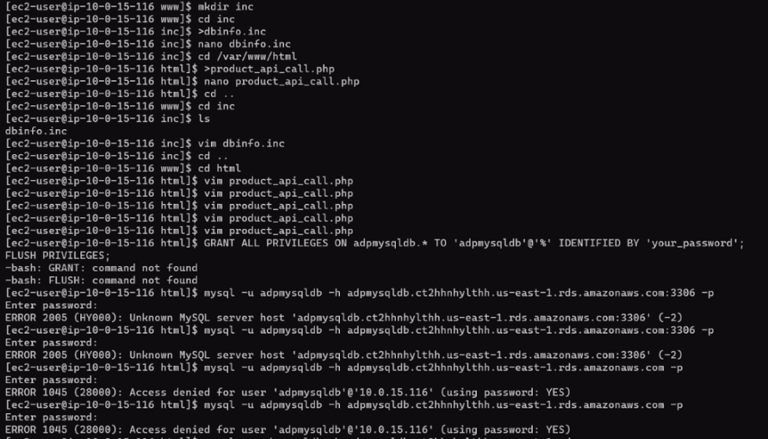

Command to log into a MySQL database

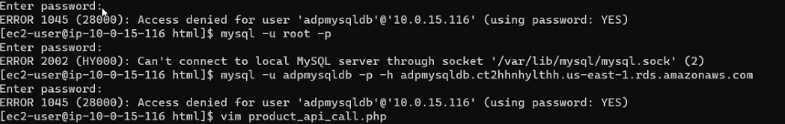

Firewall check (Troubleshoot)

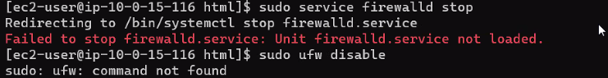

Lookup for RDS Database

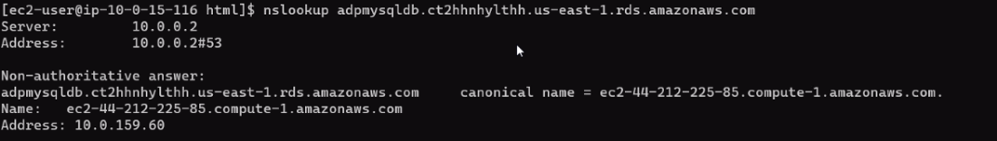

Database service failed/not found

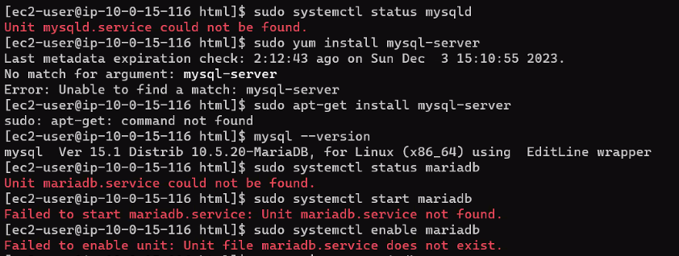

Presence of MariaDb and MySQL on Webserver



Installation and Finding Db services

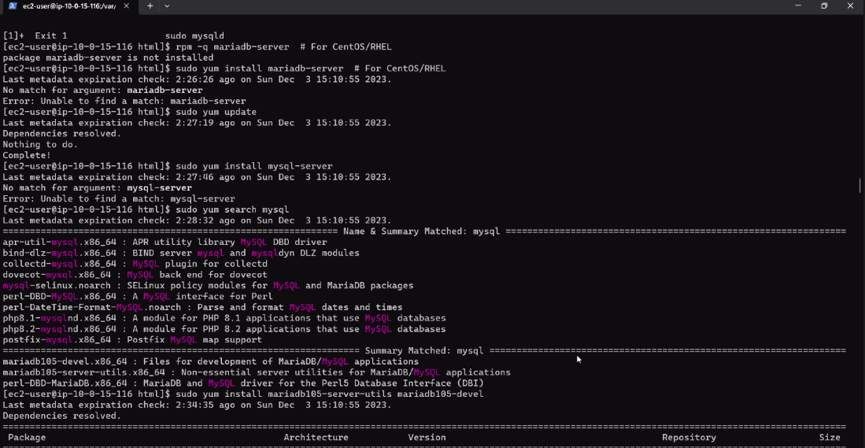

Unable to connect to RDS and MySQL Database

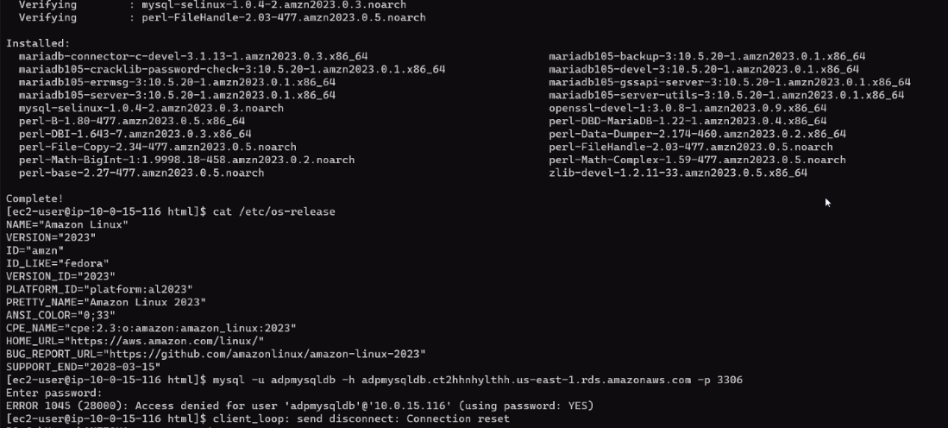

While facing challenges in establishing seamless communication between RDS - MySQL and the EC2 instance hosting our website, our team embarked on an exhaustive troubleshooting journey. Our efforts covered the review and adjustment of security rules governing both inbound and outbound traffic, a fine-tuning of IAM roles, and a modification of CloudFront policies. Despite these systematic measures, the persistent connection issues prompted us to explore deeper solutions.

In our pursuit of resolution, we went a step further by attempting a reinstallation of critical components such as MySQL, PHP, and MariaDB, with the hope of addressing potential software-related issues. Despite these comprehensive measures, the intricate task of achieving effective communication between RDS – MySQL and the EC2 instance, along with its associated website, remained a challenge. Our team continues to explore alternative strategies and remains committed to identifying a robust solution to this intricate issue.

### Screenshots

Until now, we were able to get the web server functional, install services, get permission of folders and upload the code to the server

Files Migration/Creation on Web Server

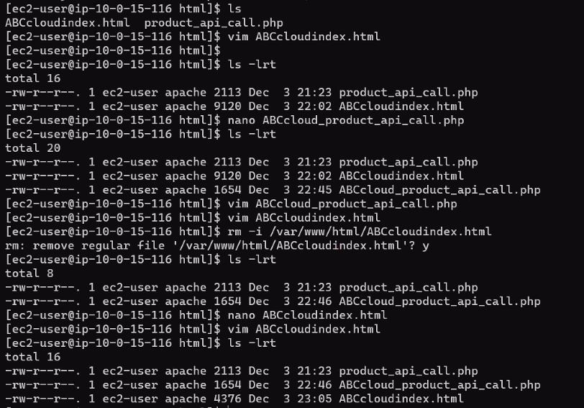

Display of WebPage using WebServer IP

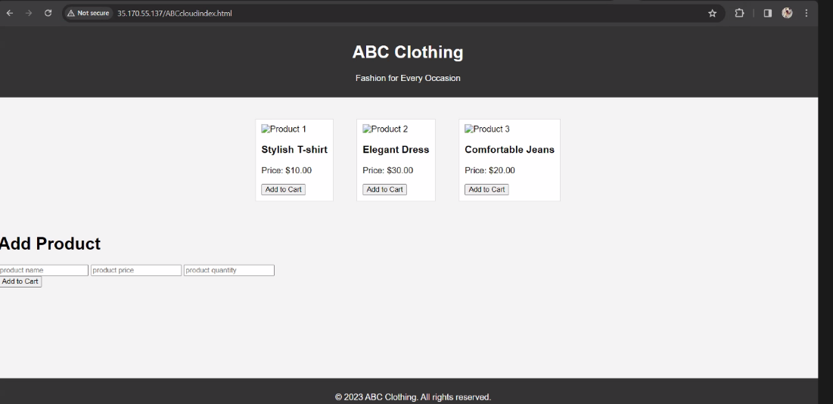

#### S3 Storage

Creation of S3 Bucket

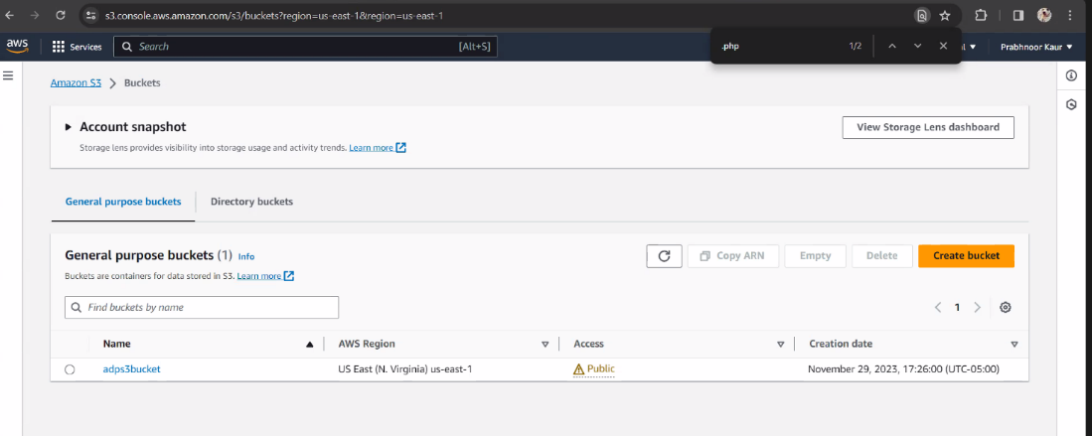

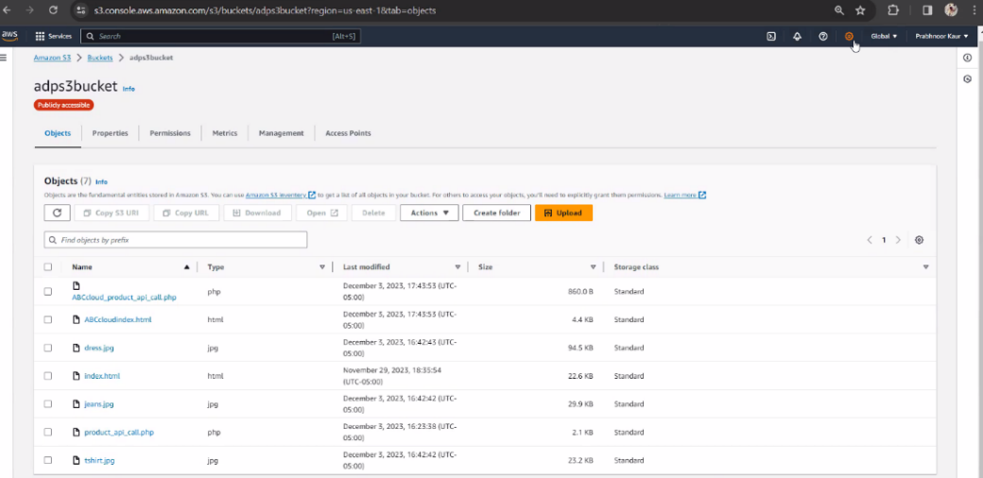

Permission and Policies

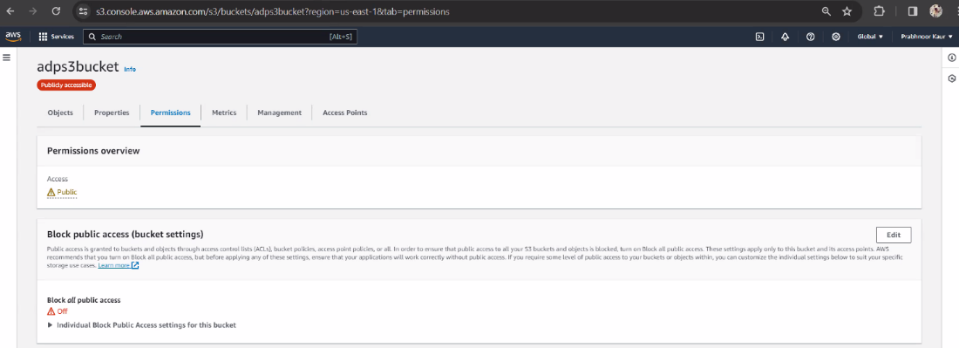

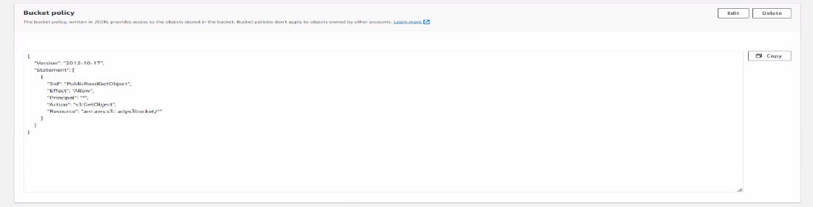

Files of S3 Bucket on Webserver

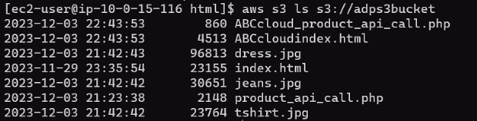

Launch of website using S3 end point

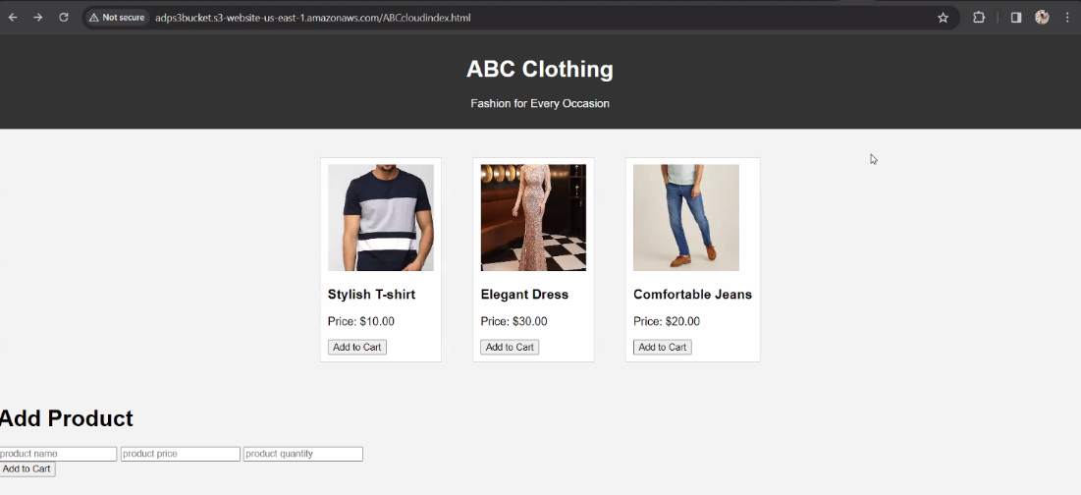

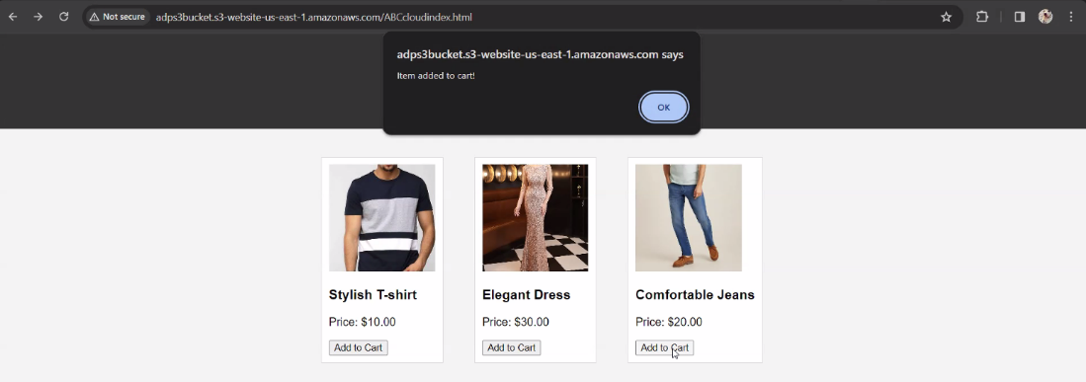

Amazon CloudFront as CDN

Distributions Created

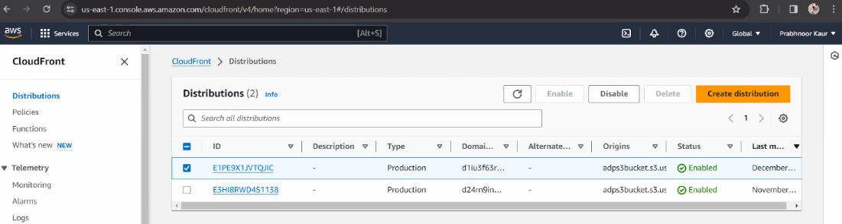

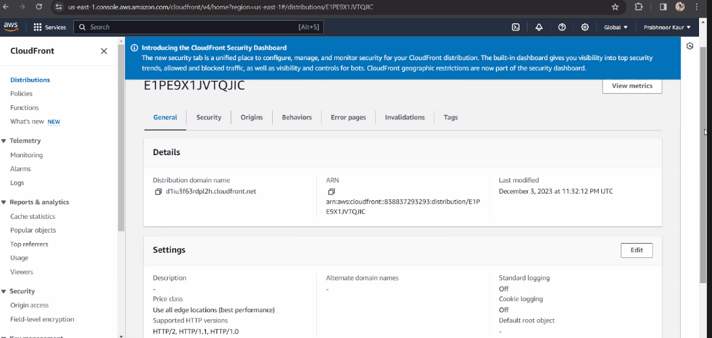

Connecting CloudFront and S3 (Origins and Behavior)

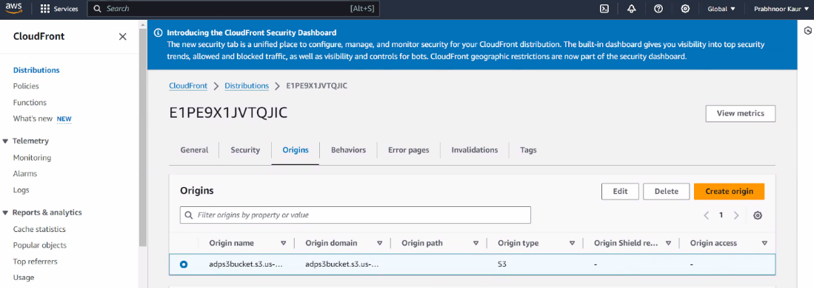

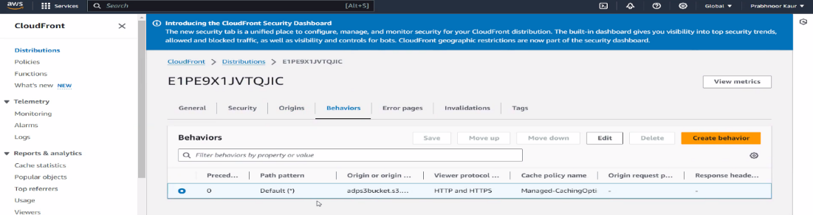

Display of Webpage using CloudFront distribution domain name

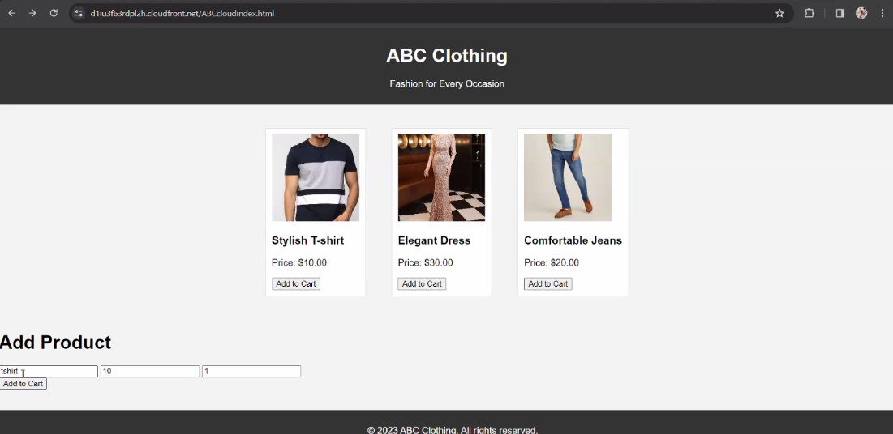

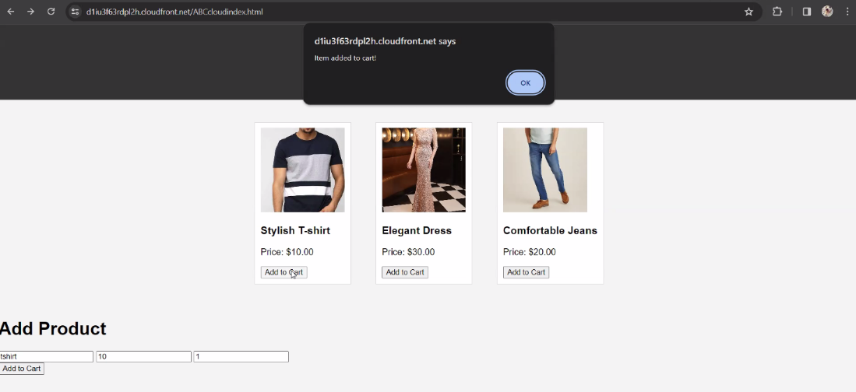

### Security

Security Groups

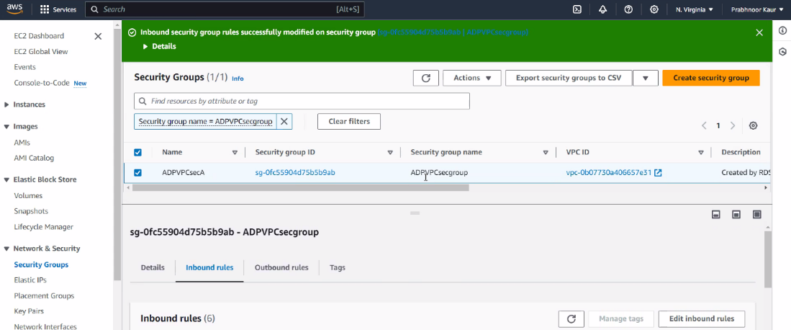

Inbound rules

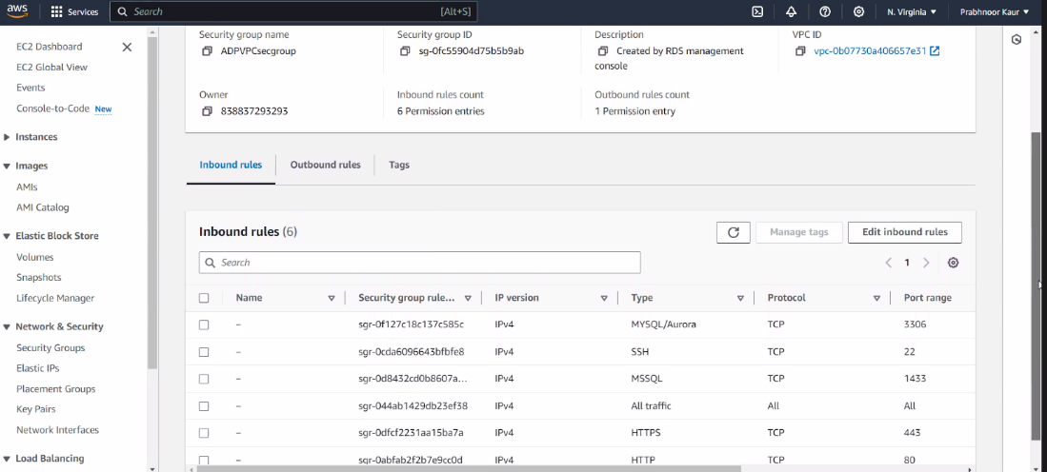

Security details

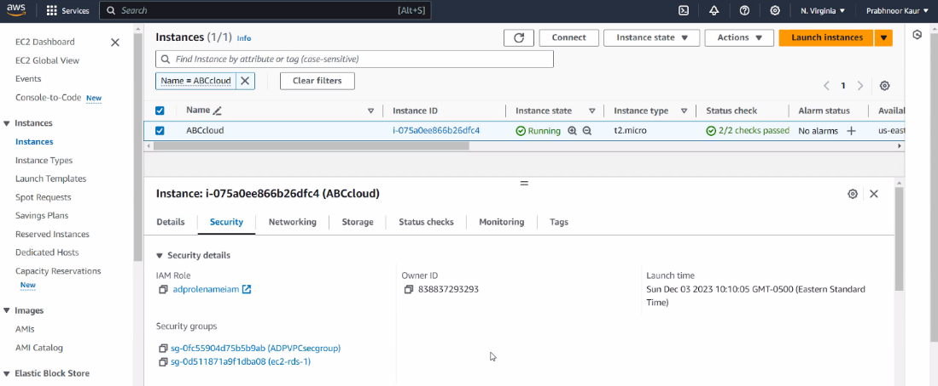

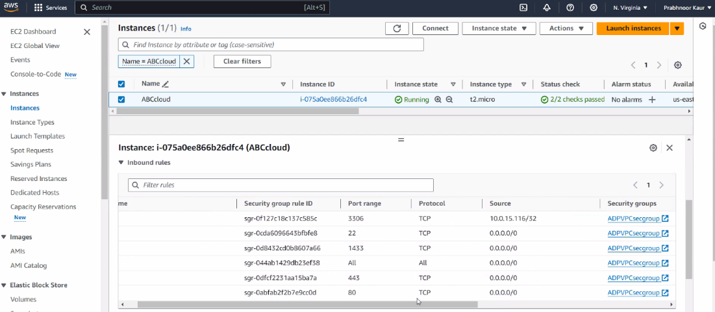

Outbound rules

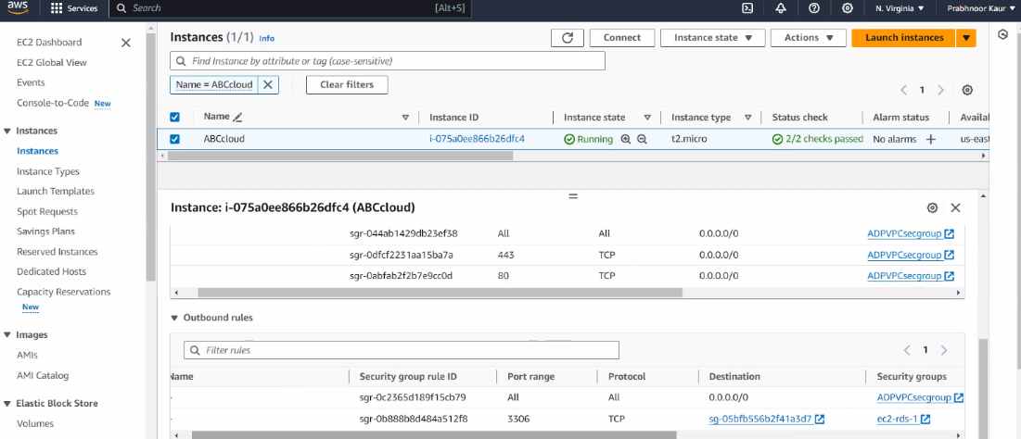

AWS Identity Access Management

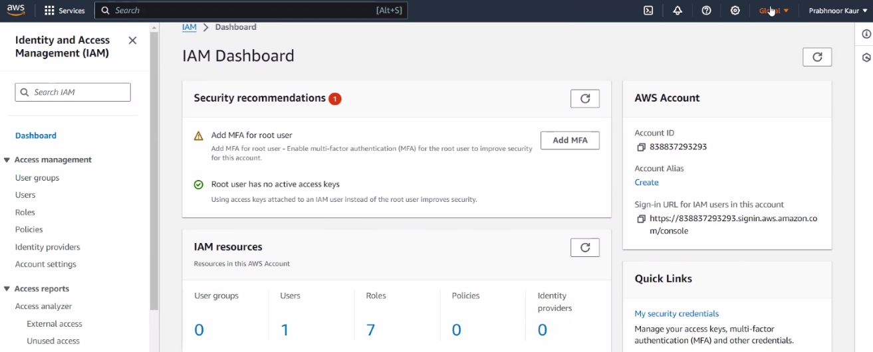

IAM roles

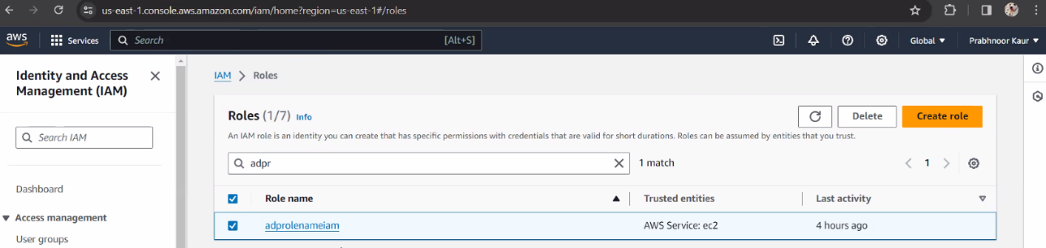

IAM roles (permissions policies and trusted entities)

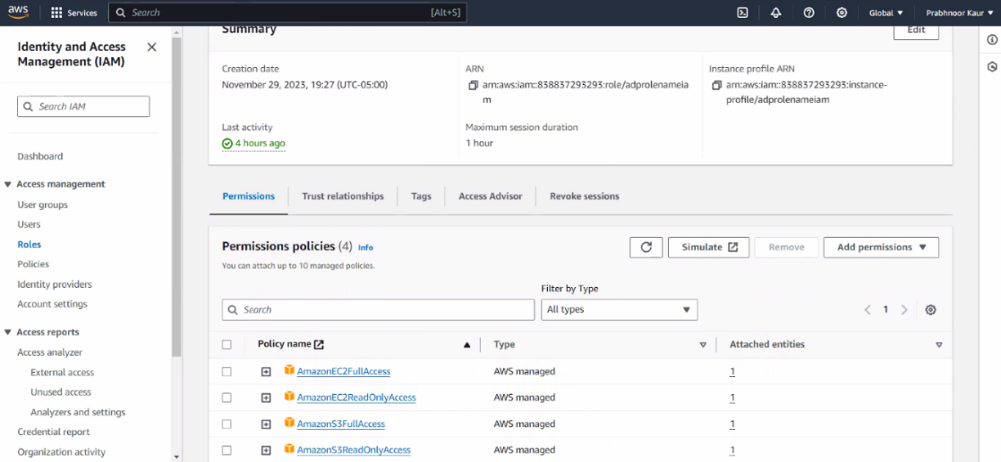

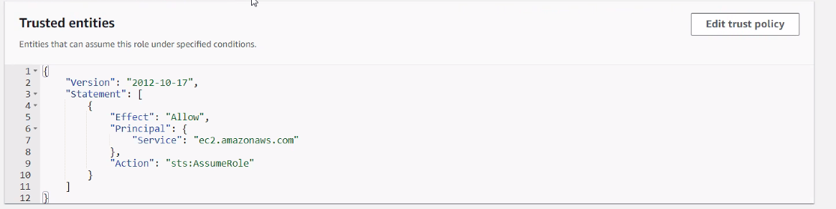

IAM Users

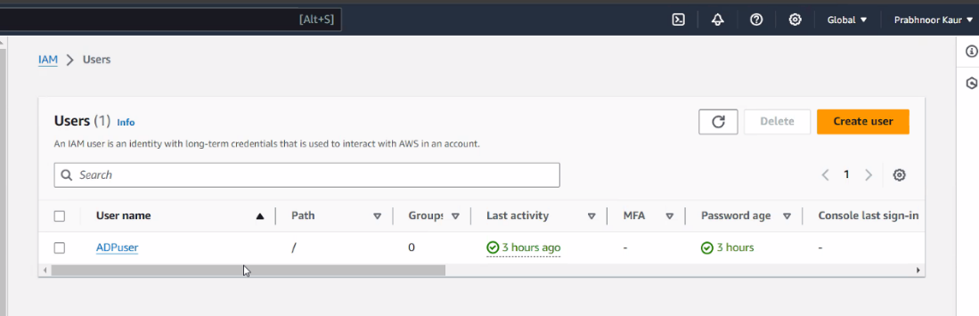

IAM users (permissions policies, access keys and tags)

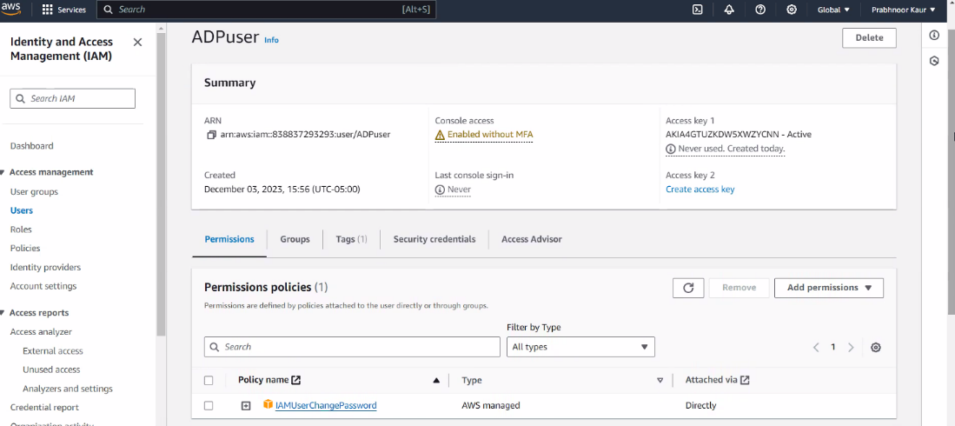

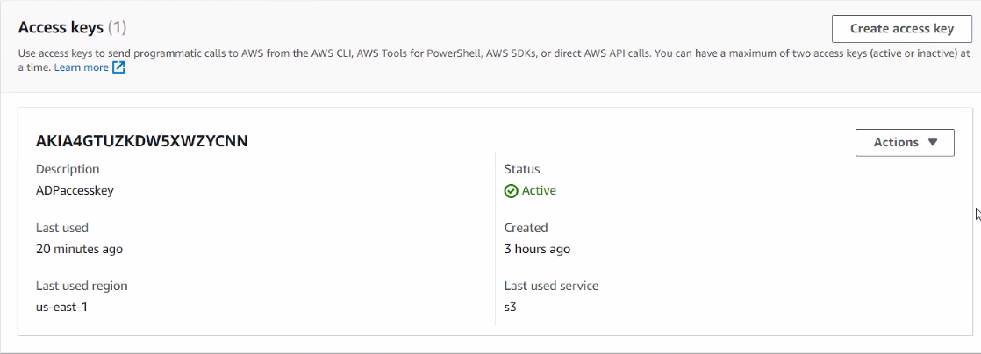

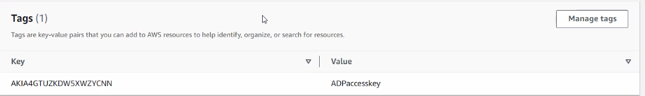

CLI AWS Configure

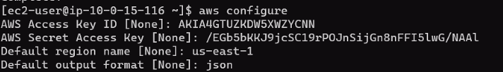

Scalability

LoadBalancer

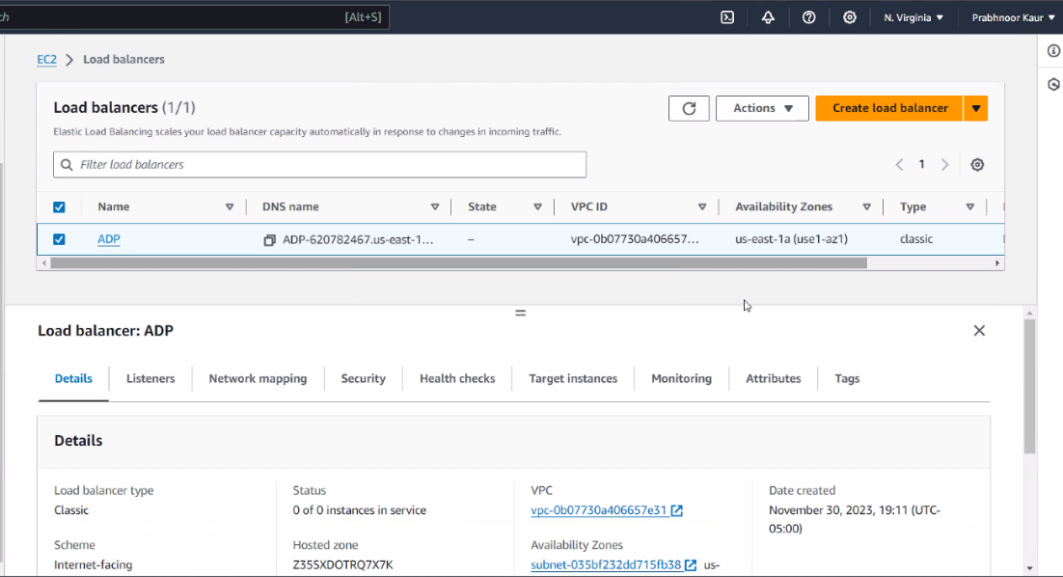

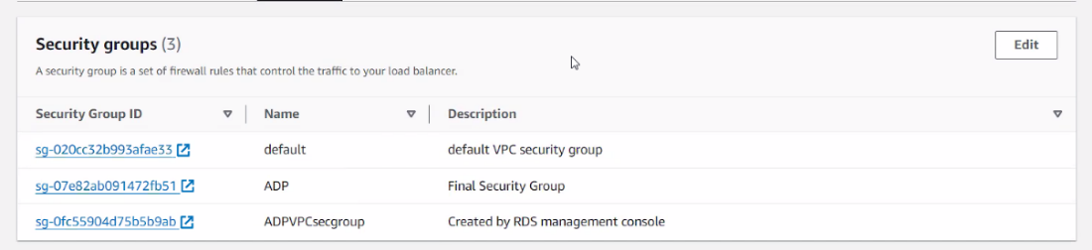

Auto Scaling Group

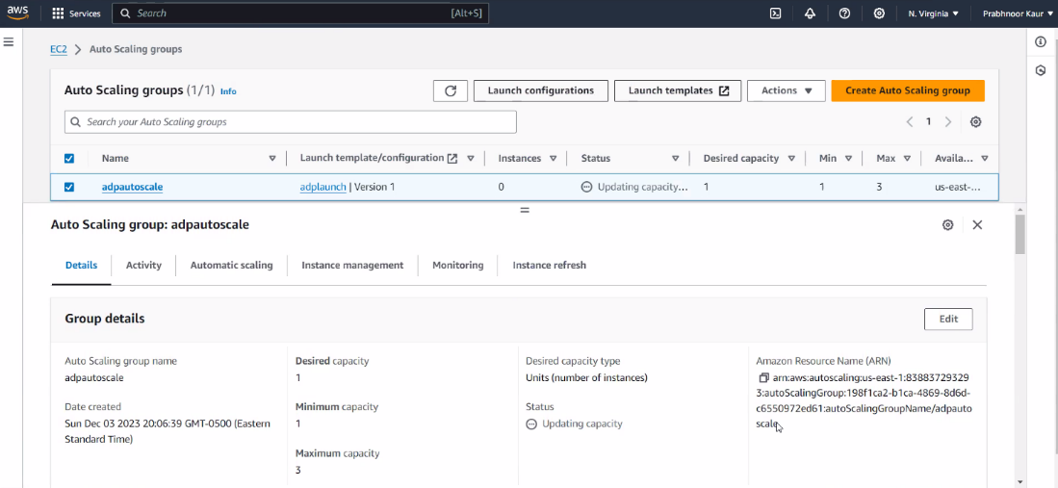

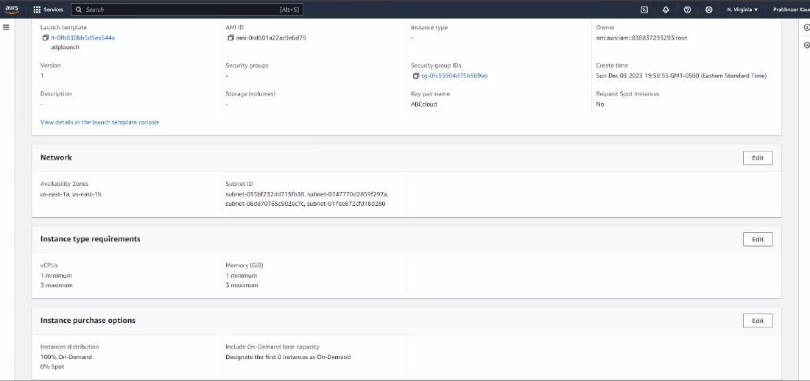

Cost Optimization and Management

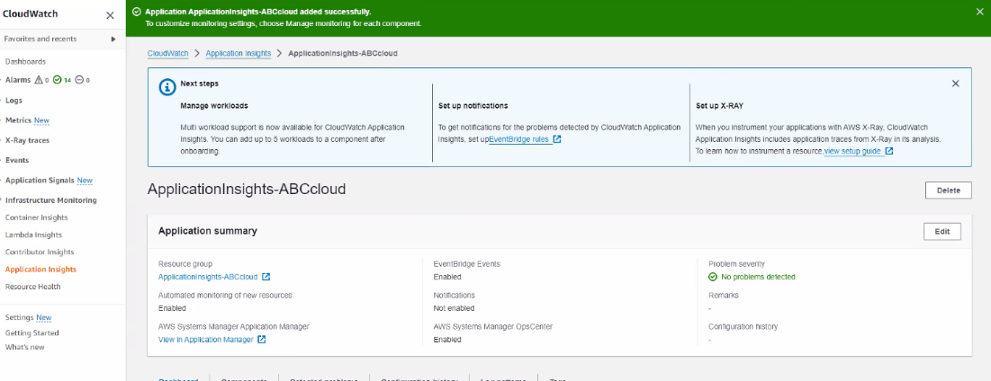

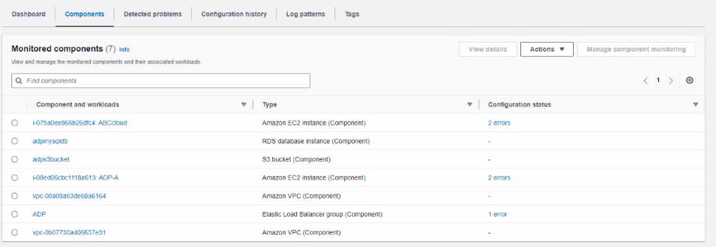

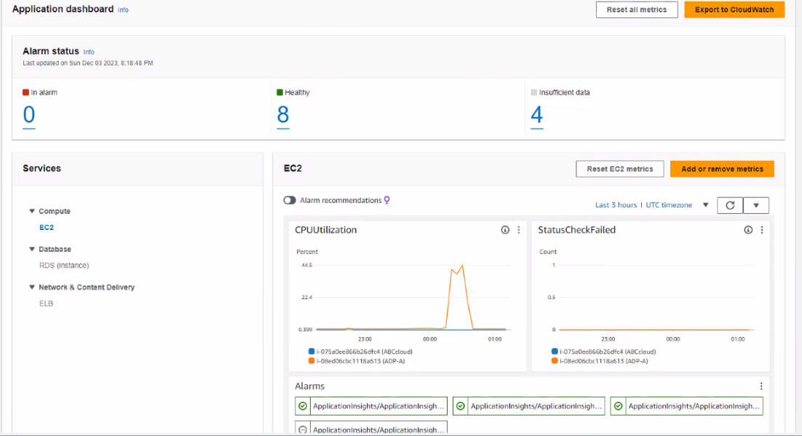

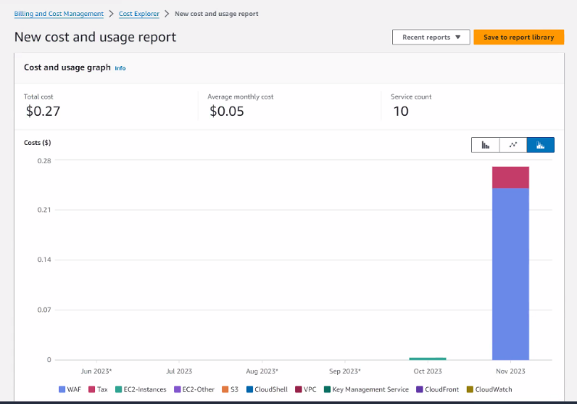

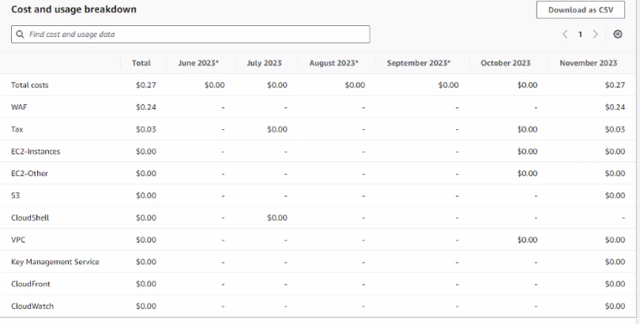

## Reflection

Taking on AWS and its plethora of services, such as EC2, S3, CloudFront, IAM, and Auto Scaling, truly opened our eyes. It was more than just learning each service separately and knowing how they all worked together to create a reliable e-commerce platform for ABC Clothing. This was more than a technical exercise; it felt like putting together a complicated jigsaw to guarantee everything was scalable and safe.

Going over ABC Clothing's current setup was a thorough assessment. We used the "lift and shift" method for cloud migration. That means we had to investigate their server structure, database, and how they manage their digital assets. We needed to ensure that when we moved everything to the cloud, everything would operate just as well, if not better.

One of the most challenging aspects was balancing top-tier security with our budget. SSL/TLS certificates are essential for secure websites. However, the fees exceeded our expectations. As a result, we had to think on our feet and take a different approach, establishing a security group for HTTP and ICMP access. It was a difficult decision, but it taught us how to adapt and innovate our responses. Then there was the RDS - MySQL - EC2 instance connectivity issue. Despite our best efforts, including rewriting security rules and reinstalling software, the problem persisted. It showed us that sometimes, in IT, you have to keep chipping away at an issue, trying multiple approaches until something clicks.

This project was about more than simply learning about cloud computing; it was about seeing it in operation, appreciating the value of careful preparation, and how to balance security requirements with financial limits. It's been an incredible learning experience for us in technical abilities, problem-solving, and strategic thinking. Looking back, we can see how much we've developed and learned from this endeavor. It prepares us with solid abilities and experiences for whatever the fast-paced world of cloud computing has in store for us next.

## References

* Scharf, Jim. “Writing IAM Policies: How to Grant Access to an Amazon S3 Bucket | AWS Security Blog.” Amazon Web Services, <https://www.facebook.com/amazonwebservices>, 6 May 2013, <https://aws.amazon.com/blogs/security/writing-iam-policies-how-to-grant-access-to-an-amazon-s3-bucket/>.
* Install a Web Server on Your EC2 Instance - Amazon Relational Database Service. <https://docs.aws.amazon.com/AmazonRDS/latest/UserGuide/CHAP_Tutorials.WebServerDB.CreateWebServer.html>. Accessed 4 Dec. 2023.
* CloudYeti. AWS Lab: Deploy a RDS Instance and Connect It to a Web Page. YouTube, 10 Oct. 2017, <https://www.youtube.com/watch?v=4L-mJc3XakU>.
* Official. “Troubleshoot Connectivity Issues with Amazon VPC Gateway Endpoints | AWS Re:Post.” Amazon Web Services, Inc., 15 Dec. 2017, <https://repost.aws/knowledge-center/connect-s3-vpc-endpoint>.
* Official. “Grant an EC2 Instance Access to an S3 Bucket | AWS Re:Post.” Amazon Web Services, Inc., 17 Mar. 2020, <https://repost.aws/knowledge-center/ec2-instance-access-s3-bucket>.
* Official. “Download an AWS KMS-Encrypted Object from Amazon S3 | AWS Re:Post.” Amazon Web Services, Inc., 8 Feb. 2019, <https://repost.aws/knowledge-center/decrypt-kms-encrypted-objects-s3>.
* “Content Delivery Network Tutorials | CDN, Setting up Amazon S3 Distribution| Amazon CloudFront.” Amazon Web Services, Inc., 15 Nov. 2023, <https://aws.amazon.com/cloudfront/getting-started/S3/>.
* ---. “Use CloudFront to Serve a Static Website Hosted on Amazon S3 | AWS Re:Post.” Amazon Web Services, Inc., 26 June 2018, <https://repost.aws/knowledge-center/cloudfront-serve-static-website>.